**Project Development Phase**

**Sprint - 1**

|  |  |
| --- | --- |
| Date & Team ID | 28th October 2022 &  PNT2022TMID47097 |
| Project Name | Deep Learning Fundus Image Analysis for Early Detection of Diabetic Retinopathy |

# Sprint Plan

Define the initial stages of the problem requirement.

Draw and understand the flowchart of the sprint

Assign tasks to each teammate

# Team Tasks

* As a user, I can register for the application by entering my email, password, and confirming my password.
* As a user, I will receive confirmation email once I have registered for the application
* As a user, I can log into the application by entering email & password

# Progress

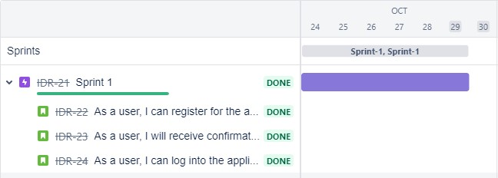

# Sprint tracker

start date end date current sprint points

24 Oct 2022 to 29 Oct 2022 20 sprint points

**Velocity for Sprint-1 = 20/8 = 2.5**

# Code Snippet

|  |
| --- |
| @ app.route('/register',*methods*=["GET","POST"]) def register(): if request.method == "POST":  name = request.form.get("name") mail = request.form.get("emailid") mobile = request.form.get("num") pswd = request.form.get("pass") data = {  'name': name,  'mail': mail,  'mobile': mobile,  'psw': pswd  } print(data) query = {'mail': {'$eq': data['mail']}} docs = my_database.get_query_result(query) print(docs) print(len(docs.all())) if (len(docs.all()) == 0):  url = my_database.create_document(data)  return render_template("register.html", *pred*=" Registration Successful , please login using your details ") else:  return render_template('register.html', *pred*=" You are already a member , please login using your details ") else:  return render_template('register.html') |

# Test cases

|  |  |
| --- | --- |
| **Test cases** | **Result** |
| Improper mail id given | Not registered |
| Phone number not given | Details not stored |
| Password not provided | Details not stored |
| Confirmation mail message | Sent successfully |
| Log in to the application | Successful |
| Log in to the application with wrong password | Showing error message successfully |
| Log in to the application showing other user | Improper user |
| Log in to the application using unregistered mail | Mail not found |